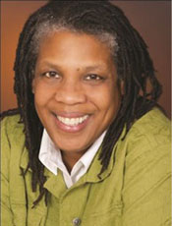
Trish Millines Dziko
Commissioner At-Large
Trish Millines Dziko founded Technology Access Foundation in 1996 after spending 15 years as a developer, designer and manager in the high tech industry. A native of New Jersey who attended Monmouth College (now Monmouth University) on a basketball scholarship, she graduated with a B.S. in Computer Science in 1979 at a time when few people of color and few women were entering the field. Her successful career brought her to Microsoft in the mid-1980s, just as the pioneering software company was set to become a worldwide brand.

Over the next decade of tremendous growth, she saw very little change in the high tech industry: women and people of color remained grossly underrepresented. After looking closely at the problem as Microsoft’s first Sr. Diversity Administrator, she determined the only solution was to increase the number of qualified people graduating from college. She traced the root of the problem to the lack of access to rigorous, relevant technology training in our public schools, particularly those in traditionally underserved communities of color. Trish left Microsoft in 1996, the same year she founded TAF.

In addition to her work at TAF, Trish remains a committed, proactive leader and serves on the boards of several organizations that focus on children and education. Trish has received dozens of local and national awards for her work improving the educational opportunities for children of color.

Trish and her partner live on Vashon Island and are the proud parents of 4 children.

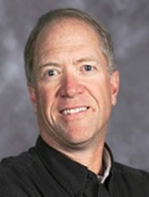
Kevin Jacka
Kevin Jacka is currently Superintendent of the Mary Walker School District in Springdale, WA, and has been in this position for the past eight years. His career in education spans 26 years, during which time he has been a teacher, coach and Superintendent.

Mr. Jacka coordinated the development of the PREP Consortium (Panorama Rural Education Partnership) consisting of 10 member school districts. As the lead Superintendent, he collaborates with the other member districts, all of which are tasked with the mission of bringing/sharing resources and costs, of establishing a college/career-going culture, and of reforming education within the Consortium.

As the lead Superintendent of the Rural Alliance, Mr. Jacka also coordinates the development of its 48 school districts, six community colleges, multiple non-profits and four universities that make up the Rural Alliance collaboration, focusing on college readiness and the transition between P-12 and post-secondary education.

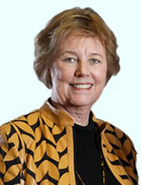
Dr. Margit McGuire
Margit E. McGuire is Director and Professor of Teacher Education at Seattle University and former president of the National Council for the Social Studies (NCSS) and a recipient of the Washington Award for Excellence in Teacher Preparation. She has presented nationally and internationally on topics related to social studies and teacher preparati on. Her leadership positions have included the National Geographic Literacy Council, NAEP Civics Advisory Board, and chairperson of the Elementary Social Studies Framework for Washington’s Office of Superintendent of Public Instruction.

Currently she serves as Washington State's liaison for higher education for the national Teacher Performance Assessment (edTPA). She is the author of the Storypath Program and recently co-edited, the NCSS Bulletin, Making a Difference: Revitalizing Elementary Social Studies.

Raymond Navarro, Jr.
Mr. Navarro, Jr. currently serves on the Yakima School District Board of Directors, and is the board’s WIAA Representative. He holds a M.Ed. in Guidance and Counseling from Heritage University and a MA in Human and Organization Systems from Fielding Graduate University. Mr. Navarro, Jr. is Director of the Central Washington University Academic Achievement Programs, Principal Investigator for the TRIO SSS and EOC Programs. He has been an active volunteer in the Yakima community for many years, serving as coach and mentor for the Southeast Yakima Saints Grid Kids Football program, and mentor for the YMCA ASPIRE Program.
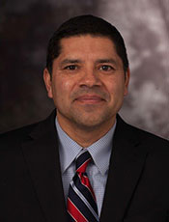
Mr. Navarro, Jr. is a proud Army veteran, serving as a Squad Leader with C Company, 307th Combat Engineer Battalion, 82nd Airborne Division at Fort Bragg, North Carolina. He currently serves as the Chair of the Yakima County Veterans Advisory Board. Mr. Navarro, Jr. has three children who have attended Washington State public schools.

Dave Quall
Dave Quall has lived in Washington all his life, attending several schools as a child of a Methodist pastor. He graduated from Seattle Pacific University with a B.A. in Education and an M.A. in Guidance and Counseling. He is a former teacher, counselor and basketball coach serving in these capacities for thirty eight years. His wife, Allene, was a 34 year veteran as a first grade teacher. He has two daughters, both active in professional careers as a surgical nurse and teacher. He has six exceptional grandchildren.
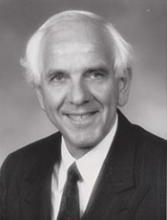
Dave served in the Legislature as a representative from 1993-2011. Eight of those years, he was chair of K-12 Education Committee. He has had a commitment to Charter Schools visiting several high quality ones throughout the country. He drafted Charter School Legislation in 1995 (HB1147), 1997-1998 (HB2019) where it passed the house with no action in the Senate. In 2004 (HB2295) passed the legislature, was signed by Gov Locke, but overturned by the voters.

Steve Sundquist
Chair
Steve Sundquist is active in the business and civic life of the Pacific Northwest through his involvement in a number of local organizations. Most recently, he was an elected School Board Director on the Seattle School Board from 2007 to 2011. In that capacity he served one year as Board President and two years as Vice President. Per school board custom he also served as a board member of Seattle’s Alliance for Education in 2011. He is currently a member of the Our Schools Coalition in Seattle.

Separately, he is serving on the boards of Climate Solutions, Conservation Northwest, and Seattle Northwest Securities Corporation; and is a member of downtown Seattle Rotary, Social Venture Partners, and Fauntleroy Church, UCC. Prior to his recent board work, Mr. Sundquist enjoyed a long career at the Russell Investment Group, where he led their IT function and National Accounts group among other responsibilities over a 22 year span ending in 2005. Mr. Sundquist earned an MBA from the University of Chicago, and a B.S. in Computer Science from Washington State University.

Steve and his wife Liann live in Seattle and are the proud parents of two daughters.

Cindi Williams
Vice Chair
Cindi Williams serves as a Principal at HCM Strategists, a leading DC-based education and health public policy firm, where she provides communications and advocacy strategy for a portfolio of clients dedicated to improving student outcomes for low income students.
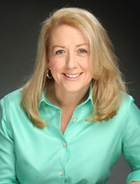
Williams joined HCM last year after having spent four years on the US leadership team at the Bill and Melinda Gates foundation. Williams served as the Director for US Communications across its domestic portfolio and worked with grantees and partners across the country to create a national dialogue about the need for education reform. Prior to joining the Gates foundation, Williams worked in a variety of policy and communications roles, serving as Senior Advisor to the U.S. Secretary of Education–where she focused on reauthorization of No Child Left Behind–along with serving as Deputy Assistant Secretary of Education for Communications and Outreach.

In addition to her work at the Department of Education, Williams served as a Special Assistant in the White House Office of Public Liaison, where she led efforts related to women's outreach, small business and education. In the aftermath of September 11, she also worked on behalf of the White House alongside the State Department and USAID to launch the US-Afghan Women's Council, a public-private partnership created to meet the needs of women in Afghanistan. Williams has worked on three Presidential campaigns and has held leadership roles in the U.S. House of Representatives and the American Red Cross. She is a member of the Bush Institute's Education Advisory Council, the U.S. Afghan Women's Council, and Northwest Center Foundation Board, the STAND for Children Advisory Board and the Center for Reinventing Public Education (CRPE) Advisory Committee.

She lives in Bellevue with her husband, Tony, and two boys Jacob and Joshua.

Larry Wright
Larry Wright is the Chief Operating Officer at the College Success Foundation, Washington State. Prior to joining the foundation, he served as CEO of the National Mentoring Partnership in Washington DC and as executive director of their Washington State affiliate, Washington State Mentors.

He is committed to community service and sits on the boards of the Washington State Mentors and Big Brothers Big Sisters of Puget Sound.
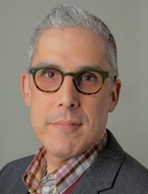
He received his PhD in communication from the University of Wisconsin-Madison and his MA and BA from Washington State University. He lives in Sammamish with his wife and two children.

